Title: ‘Unconventional’ Monetary Policy
Subject: MTP 12

1. The need for Unconventional MP  2. A Model for unconventional monetary policy  3. Conventional vs Unconventional MP  4. Unconventional MP in deep  A. Forward Guidance  a. Why we need fg  b. Cathegories of fg  c. Odyssean vs Delphic forward guidance  d. Evidence on fg  B. Balance sheet Policies (QE in US, APP in EU)  a. Pure quantitative easing (size):  b. Targeted asset purchases or credit easing (Composition):  c. Overall Evidence  2. Looking ahead: Inflation target vs price level target | During 1991, 2001 and 2008 recessions FED reacted to u increase with cuts in FFR. Nevertheless this period was associated with very low inflation. Low rates did not provide enough stimulus to boost the economy. In fact, in 2008 Taylor Rule (which has worked super well recently) arrived at predicting FFR should have been set to -5%! ---> Desired amount of a monetary policy stimulus was not realizable = MP funds rate shortfall. In 2009 we risked to fall in a liquidity trap, a situation in which the S-T nominal interest rate is zero. No more room to create stimulus, but inflation remains low. i = 0 = no room for further expansionary policy --> insufficient stimulus --> deflation --> higher real rates (r = i – π^{e} )--> detrimental effect to GDP ---> deflation ---> higher real rates etc  --> during these crises you see super low nominal rates (i) but also deflation --> real rates are super high (10% during the great Depression)  Two main historical episodes of liquidity trap: Great Depression and Japan during the Great Slump (mid 1990s )  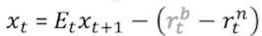  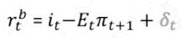  New IS curve:  Where $r_{t}^{b}$ is the real interest rate faced by households and firms (adjust by adding risk premium δ):  + Ideally, consider LT rates, not ST, by averaging each subsequent period ST rates (we do not to keep it simple)  *Recall: the natural interest rate is the interest rate that would prevail when the economy is at full employment and stable inflation  Substitute in expression for $r_{t}^{b}:$ $x_{t}=E_{t}x_{t+1}-(i_{t}- E_{t}π_{t+1}+δ_{τ}- r_{t}^{n})$  But there is far more! $x_{t+1}$can be rewritten as: $x_{t+1}=E_{t+1}x_{t+2}-(i_{t+1}- E_{t+1}π_{t+2}+δ_{τ+1}- r_{t+1}^{n})$  Now we can fill $x_{t+1}$ into $x_{t}$ and again $x_{t+1}$ into $x_{t+2}$ etc you get:  --> there are several ways to stimulate aggregate demand:  - ﻿﻿Cut the ST rate i_{t} (ZLB may forbid me to do this)  - ﻿﻿Reduce interest rate differentials δt  - Cutting expected future short-term nominal rates E_{t}i_{t+s}  - Reducing expected future interest rate differentials (risk and term premia), E_{t}δ_{t+s}  - Raise inflation expectations E_{t}π_{t+s}  So if the CB is able to target future expectations it is possible to make $x_{t+1}$ go up --> Thanks to Consumption smoothing Consumers will consume more today = xt goes up!  Conventional MP  Policy directed at achieving a target level for the short-term overnight nominal rate  Unconventional MP  Policies aimed at lowering the cost and increasing the availability of credit to households, banks and businesses. basically, target E_{t}i_{t+s}, E_{t}δ_{t+s}, E_{t}π_{t+s}, δt + extra: Facilitate the credit flow (to restore the link btw policy rate and other rates) + Influence the exchange rate  Note: Indeed, while monetary policy is typically described in terms of the current level of the short-term policy rate, an expansionary monetary policy can also be described in terms of:  – weak real exchange rate  – low S-T real interest rate  – low L-T real interest rates in various credit markets  Unconventional monetary policy is mainly composed by two policies:  A. Forward guidance  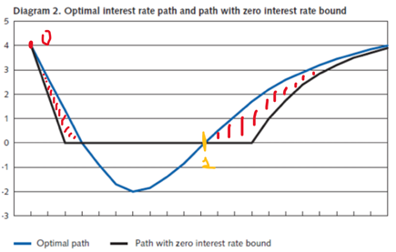  Why we need forward guidance and the role of credibility  Forward guidance consists of communicating to the public the stance of future monetary policy in the hope of changing the public’s expectations. Imagine:  We need negative rates (blue) but we cannot go below zero (black)  The black path achieves same stimulus by decreasing interest rates before and keeping low rates for longer  So, CB can achieve the results of the optimum path to exit the crisis even if it cannot go below 0. BUT credibility is key: once the CB is in 1 it should keep a more-than-optimal expansionary policy. In 0 people had formulated expectations on the fact that CB had promised to be very expansionary also after 1: this was key in allowing the CB to obtain the same effects of the Optimum path. However now CB has incentive to deviate, problem of time-inconsistency: lack of a motive ex-post to be as expansionary as one wanted people earlier to expect! (credibility at stake!)  Three broad categories of forward guidance  I. Pure qualitative forward guidance  Fed (2008-09): “The Committee currently anticipates that policy accommodation will be maintained for an extended period”.  No end-date, no threshold, no reference to underlying conditions, no forecast of likely evolution of policy rates  II. Calendar-based guidance  Fed (2011): “…exceptionally low levels at least through mid-2013”.  III. Threshold-based guidance  Fed (2012): “… as long as the unemployment rate remains above 6.5 percent, inflation between one and two years ahead is projected to be no more than 0.5% points above the 2% LR goal, and LT inflation expectations continue to be well anchored”.  Odyssean vs Delphic forward guidance  Suppose the CB makes a statement about keeping interest rates low for some time. There is a subtle distinction here (note: same final effect): Is it because…  A. Odyssean/commitment fg: The CB is committing to keeping interest rates low (even if the economy recovers)?  In the first case the CB is making a promise: Just as Odysseus bound himself to his ship's mast to resist the temptation of the Sirens' song, a CB can improve welfare by publicly committing to a time-inconsistent plan that uses expectations of suboptimal future outcomes to improve current economic conditions. The first case – commitment – is the most effective form of forward guidance and the stricter academic concept of forward guidance. However, promises are hard to keep because, when the economy recovers, the CB will be tempted to change its mind (time-inconsistency)  B. Delphic/communication fg: The CB forecasts that the economy will be in a recession for a long time (CB is providing some information)?  In the second case the CB is offering its projections about future policy decisions. Just as the oracle Delphi, who forecasted the future but promised nothing, CBs discuss future developments in macro fundamentals and their likely responses  Evidence on forward guidance  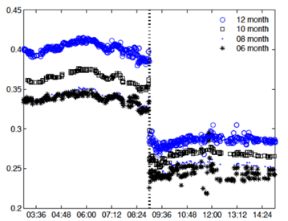  Do announcements affect expectations?  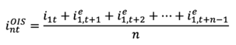  y axis is the OIS rate (LT rate depending on ST policy rates expectations, risk free!)  Announcements:  I. Affect immediately OIS  II. i12 drops more than i6! Now, expected policy rates fall and fall more at longer horizons; that is, the yield curve not only falls but it flattens; a steepening of the curve would instead be expected from a simple announcement of a cut in policy rate target. Markets realize a future CB commitment in keeping rates low.  Policies aimed at changing aggregate demand by varying either the size or the composition of the CB B/S even in the absence of any change in the target for overnight interest rates. Up to now in conventional monetary policy we conceived B/S policies as the determinants of the monetary base used to conduct MP in the limited reserves framework, with the aim of changing the overnight rate. Then, we said that in the ample reserve regime shifts in the monetary base do not affect the overnight rate. Here, with respect to unconventional monetary policy, we explore how they affect AD even if they do not touch the overnight rate.  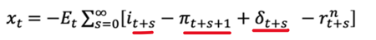  Basically in the ample reserves regime we use B/S policies to target:  Two types of B/S policies (note that in recent years, the press has come to use the term «quantitative easing» to refer to both):  B/S policies focused on the expansion of the liabilities of the CB (the monetary base). Aim: to perform as in the optimal path we must make people understand we will make more-than-optimal (more than expected) expansionary policies after 1.  We increase reserves: 1. to create inflation in the current period (as in the optimal path) 2. to create more inflation than expected after t1  If the increase in liabilities is perceived to be lasting longer than the crises markets understand the additional liquidity will stay around for a while, thus raising future expected inflation (E_{t}π_{t+s}). If it is perceived as temporary future expectations do not change a lot. (ex. Pure QE in Japan in early 2000s was expected to be temporary and consequently the policy had little effect).  Evidence: does pure QE create Inflation?  That’s what it is intended for!! Evidence: risk of hyperinflation is almost non-existent; Except in cases where monetary financing of the government is performed (Zimbabwe, 2008-09). Monetary financing is banned by law in many countries:  a. CB not allowed to buy government bonds in primary market (directly from government)  b. CB subject to restrictions on bond purchases in secondary market  B/S policies focused on the composition and size of the assets of the central bank.  Focus on the type of assets purchased:  I. ST vs LT bonds  Traditionally only S-T Gov bonds were bought (the usual tool for OMO). In QE we buy MAINLY buy LT.  There are two channels through which purchases of L-T government bonds can have expansionary effects:  i. Term premium and portfolio balance channel (δ_{t}), main channel:  CBs, by buying LT bonds, change D conditions in the market for LT bonds, raise their price and lower L-T interest rates via a reduction in term premia (key is that assets in different maturities are not perfect substitutes so that D and S conditions can affect their prices)  --> PF balance effects then spread the effect to other assets prices (ex. other LT corporate bonds are affected)  ii. Signaling channel (E_{t}i_{t+s}):  credibly support forward guidance: The CB would incur losses on long-term bonds if the ST interest rate is raised before maturity.  II. Other assets  There are two channels through which purchases of other assets can have expansionary effects.  i. Market functioning channel (δt):  CB Intervention (not necessary needs to buy, can also grant loans) leads to  ii. lower interest rates in specific credit markets, thus facilitating the flow of credit in markets where liquidity is low and panic widespread and reducing differentials between interest rates on various assets (i.e., commercial paper, corporate bonds and MBs).  Notice: this channel is very key in the EU: ECB views unconventional as complement to conventional. Basically EU conceives unconventional MP as a tool to restore the traditional market functioning channel.  APP announcements have clear immediate effect on bond yields (left panel) and stock mkt (right panel)  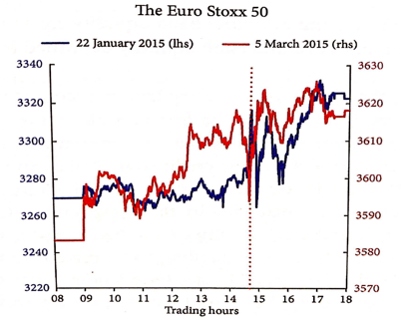  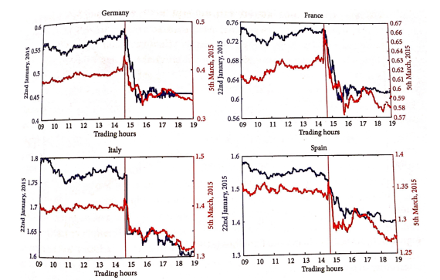  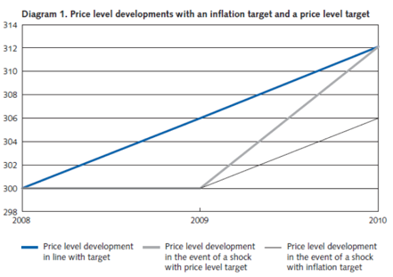  Inflation target is non-cumulative.  Target 2%. Now imagine 2008-2009 deep recession block prices. Going back to target means creating steep inflation in 2009. However as you can see we did not menagi to compensate. In 2009 you should have targeted 4% to have an overall 2% average inflation in the period, but you had to target inflation at 2%: no compensation.  Two possible Solutions:  A. Target average MR inflation level (as FED said in the last meetings). Problem: yeah but at what’s time range?  B. Target price level, not inflation level. Price level target compensates for past deviations. Nice because pcrice level targets should increase immediately inflation expectations, bc people know inflation will be created to compensate. Time inconsistency problem is still present: a price level target corresponds to allowing for an overshooting of the target in terms of inflation after the crisis; problem of time-inconsistency: lack of a motive ex-post to be as expansionary as one wanted people earlier to expect  Note: No more unconventional, these tools are used normally right now

